**BotanoTech**



Students imagine themselves as employees of a (fictitious) San Diego Biotech company “Botanotech”. The company develops anti-cancer medications and has identified a promising compound in broccoli (which actually is a source of at least one real anti-cancer drug currently in development called sinigrin). However, closely related plants may be a better source and the students’ job for the week is to identify the closest relative of broccoli. They consider 3 candidates: broccoli rabe, cauliflower and pea. First they make phenotypic observations leading them to propose a hypothesis as to which is the closest relative of broccoli. Then they undertake genomic investigation, examining relatedness at the DNA level (extracting DNA, using it for RAPD PCR, running the PCR products on a gel, and examining banding patterns to determine relatedness). On the last day they draw conclusions based on their evidence, culminating in construction of a phylogenetic tree for these four plant species. This module is designed to expand and deepen student understanding of CA 7th grade life sciences standards while utilizing these concepts in a real world investigation of an important problem. In addition, students get hands on experience with technologies and tools involved in genomics and biotechnology.

CA 7th Grade Life Science Standards addressed by this module (most relevant standards in **bold**):

* **Students know the nucleus is the repository for genetic information in plant and animal cells**.
* Students know sexual reproduction produces offspring that inherit half their genes from each parent.
* Students know an inherited trait can be determined by one or more genes.
* **Students know plant and animal cells contain many thousands of different genes and typically have two copies of every gene. The two copies (or alleles) of the gene may or may not be identical**, and one may be dominant in determining the phenotype while the other is recessive.
* **Students know DNA (deoxyribonucleic acid) is the genetic material of living organisms and is located in the chromosomes of each cell.**
* **Students know both genetic variation and environmental factors are causes of evolution and diversity of organisms**.
* **Students know how independent lines of evidence from geology, fossils, and comparative anatomy provide the bases for the theory of evolution**
* **Students know how to construct a simple branching diagram to classify living groups of organisms by shared derived characteristics** and how to expand the diagram to include fossil organisms

**Day 1 part A: Introduction, Phenotypic Observations, Hypothesis**

Materials

Vegetables purchased from grocery store: broccoli, cauliflower, peas (preferably in pods), broccoli rabe

Quantities of vegetables for 4-6 classes for the week (Day 1 & 2):

• 3 Heads of Cauliflower

• 4 Heads of Broccoli

• 3-4 bunches of Broccoli Rabe (somewhat hard to find, more likely to find in health food/specialty groceries like Sprouts, Whole Foods, etc.)

• Only a small amount of fresh pea pods will be necessary for showing students on day 1, as dried peas will be used for DNA extraction the following day.

Seedlings for each plant species, approx. 3-4 weeks old. See notes below.

Student Notebooks

Getting Ready

Have Day 1 PowerPoint ready

Have plants and vegetables ready

Recommended Timing:

Intro to Botanotech, distribution of notebooks 9:00 (5 min)

Day 1 PowerPoint 9:05 (10 min)

Plant observations (discussion of veggies, individual time) 9:15 (15 min)

Students write hypotheses 9:30 (5 min)

Class discussion of hypotheses 9:35 (5 min)

Finished 9:40

Grew plants in greenhouse at UCSD in our Sunshine Mix potting soil (any potting soil would do). Recommend use of following disposable flats available from McConkey Co:

East Jordan Plastics Germination Flat (EJPFG) with holes 10.875 x 21.25 x 1.25 in, 100/cs, about $100

Inserts to go with these flats: EJP1801-200 (Cell Size: 3.125" x 3.125" x 2.25" so 18 cells per flat, I think 200 sheets per case, around $80) or EJP1201-200 (Cell Size: 3.0625" x 4.75" x 2.25" so 12 cells per flat, 200/cs, same price)

Sow liberally and thin to a density where plants are not crowding each other

If growing these outside in the spring, you might want to start a bit earlier assuming average temps lower, maybe 4 weeks before needed.

Seeds were purchased from local nurseries: Anderson and Mission Hills.

**Day 1 Part B: DNA extraction**

Background for the Teacher

Review: <http://learn.genetics.utah.edu/content/labs/extraction/howto/>

The protocol the students will use (in their notebooks) is an adaptation of this method. Some students will substitute other plants for the peas and the volumes are slightly changed. Also, because there is less DNA in the fresh plants than the dry peas, students will not pour the extract from the beaker into individual test tubes. They will add the alcohol directly to the beaker and pass the beaker around the group so each student can spool out some DNA.

The DNA collected today is not the DNA that will actually be used for PCR, though the students do not need to know this (it is better if they think the DNA they prepare will be used, but reassure them if their prep doesn’t go well that very little DNA is needed for the PCR and there should be enough even if they can’t see DNA precipitated). The real DNA has been prepared in a lab using a different protocol.

Materials

* Student workbooks
* 200-600 ml glass beakers, 1/group
* Vegetables
* Blenders, 1/group
* Table Salt 1 container/group
* Strainer, 1/group
* Liquid Detergent 1/group
* Meat Tenderizer and microspoon (<1/8 t.) 1/class (instructor carries around)
* Isopropyl Alcohol 1/group
* Wooden Sticks or Skewers 1/student
* Knife and paper plate for cutting veggies 1/group
* 15ml tube/group to collect DNA, 1/group
* 1, 15ml spoon/group
* 1, 1ml spoon/group
* Access to water (sink)

Getting Ready

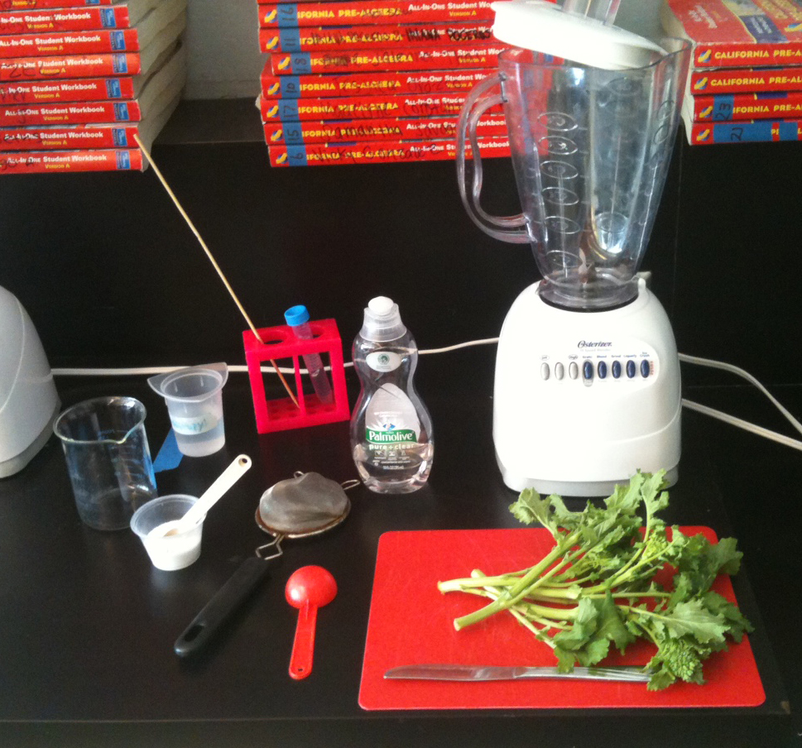Have Day 2 PowerPoint ready

Have blenders and DNA extractions materials set up at stations (1 blender and 1 vegetable/station). Recommend 4 students/station

If there is sufficient time before class, or the day before, the vegetables for the DNA extractions can be divided among classes/groups to ease prep between consecutive classes. The 15 ml “DNA collection” tubes can also be pre-filled with water to facilitate the extraction process.

**Guiding the Investigation**

Powerpoint: talk-through of DNA extraction procedure 9:40 (5 min.)

Active Investigation (DNA extraction): 9:45 (30 min.)

* Read steps together while students write pertinent information in their notes

(p. 7). Point out materials for each step.

* Students then perform the extraction as a group at one of the blender setups. **Note that students using dried peas should use only 50 ml rather than 200 ml as specified in protocol.** For broccoli and rabe, instruct students to use mainly the floral parts and not a lot of stalk tissue (for better DNA yields). For all fresh veggies be sure they chop them up into very small pieces before putting into the blender so they can get a fine grind and better DNA yields so they can see visible precipitation.
* While mixture sits for 5 minutes, teacher should demonstrate the addition of Alcohol and how to “spool” the DNA and transfer to DNA collection tube.
* Stress the importance of adding alcohol slowly, dribbling it down the inside wall of the beaker so that it floats on top of the water layer – this will produce a visible DNA precipitate at the interface that extends up into the alcohol layer and can be spooled out. If they mix the alcohol and veggie water layers, they won’t see precipitation.
* After alcohol has been added to beaker, have students pass it around and take turns carefully spooling DNA from the alcohol layer onto skewer. Dip skewers into labeled DNA collection tube containing water.
* This DNA collection tube will be saved for the next day’s PCR.

Clean up 10:15 (7 min.)

* Left over blender extracts should be poured into a garbage can or compost– not down sink drain, because pretty chunky still.
* Students do not need to clean blenders if the next class will use them for the same plant. Only the last class of the day should clean.
* Each class should rinse the beaker that contained the extract and alcohol.
* Collect one DNA sample from each group labeled for re-distribution tomorrow

**Teacher Guide Day 2: Polymerase Chain Reaction (PCR)**

Background for the Teacher

Review PCR Animation: <http://learn.genetics.utah.edu/content/labs/pcr/>

See description of RAPD PCR at the end of the teacher guide

PowerPoint Day 2

Materials

* Adjustable 2-20 µl pipettors (1 for every 2 students recommended)
* Pipette tips (1 box of for each pipettor – note that some of the pipettors at Grant require “LTS” style tips – look for this on the tip boxes. Other tips appear to fit just fine when you put them on, however they don’t make a proper seal and no liquid will be picked up!)
* Pipette lesson template, 1/desk – taped down for day.
* Wax Paper (approx. 4”x8”) 1/student
* 1.5 ml tube of colored water 1/pipettor
* Empty 0.5 ml PCR tubes 1/student – prelabeled with sample numbers
* Student DNA samples from prior day
* Eppendorf tubes, 1.5ml, for PCR mix (1 per pipet)
* Tube racks
* Plastic beakers labeled “waste” for pipette tips etc.
* Thermocycler (PCR machine) (not necessary if samples are run off site)

Getting Ready

Prepare the following:

1. For Pipette practice session:
2. Prepare a solution of dilute red food coloring (approx. 1:10 with water). Put ~1 ml of this solution in each Eppendorf tube (need one per pipette)
3. Distribute: pipettors, tips, waste containers, racks with tubes of food coloring
4. Distribute pipetting templates (1/student), cover with wax paper and tape it down (students can do this themselves)
5. For student PCRs (don’t do this until practice session is over to avoid students mixing things up):
   * 1. Label 1.5 ml Eppendorf tubes “PCR Mix” and add approx. 300 µl of water to each tube (1 per pipette)
     2. Distribute prelabeled PCR tubes – one per student, matching the species they extracted DNA from (red = rabe, blue = broccoli, green = cauliflower, magenta = pea)

**Guiding the Investigation**

**1) Day 2 PowerPoint slides 1-9 (review of yesterday, definitions, introduce concept that we are using PCR to compare parts of the genome, introduce micropipettes). ~10 min.**

**2) Pipette lesson, beginning with a few minutes demo for class. ~5 min.**

**3) Pipetting practice for students (~10 min).**

Students use colored water to practice depositing 5 and 15 µl volumes onto dots on a template. These are the same volumes they will need to use later for setting up their PCR reactions.

When this is done, collect all materials to avoid confusion with components of PCR reaction.

**4) Return to PowerPoint to introduce PCR (remaining day 2 slides, including ~2 minute animation, 10-15 min total)**

**5) Students set up PCR (10-15 min)**

Distribute materials needed for PCR reactions (PCR tubes, PCR mix, genomic DNA). To facilitate distribution of correctly labeled tubes to each person, ask students to raise their hand if they had broccoli and give them all tubes with blue stickers, etc. for each plant. Go over information about what volumes of what to mix together to assemble the reaction (students need to fill in blanks in their books with the correct information)

**6) Clean Up (5 min)**

**7)** During final 20 minutes, students can use Netbooks to review PCR animation at http://content.dnalc.org/content/c15/15475/19_polymerase_chain_reaction.mp4

and do this interactive PCR activity:

<http://learn.genetics.utah.edu/content/labs/pcr/>

This provides additional background needed to answer PCR questions in their notebooks.

**Day 3: Gel Electrophoresis**

Background for the Teacher

Review <http://learn.genetics.utah.edu/content/labs/gel/> and Day 3 Powerpoint

Materials

* P20 pipettes
* pipette tips
* plastic beakers labeled “waste”
* Flinn Scientific Pipette Practice Kit (Cat. No FB1649) containing practice gels and gel loading dye
* low melt agarose (Promega)
* gel electrophoresis unit(s) (box, gel bed, casting apparatus, combs)
* electrophoresis power supply
* DNA size markers - optional (recipe below is for Invitrogen 1kb plus ladder, see sizes pg. 3)
* 10X Gel Loading buffer
* SyberSafe gel stain
* Gel Running Buffer 1X TAE or (10X TAE and distilled water)
* Plastic wrap for wrapping up gel after it is finished running
* Grant* 1 Worksheet of Assigned Lanes (a Master Copy document)
* PCR reactions prepared offsite labeled exactly the same as the tubes given to students yesterday (the “real reactions”)

Getting Ready

1. Prepare 3% agarose gels.

This can be done day before if gels can be cooled and covered with small amount of buffer and plastic wrap or in morning before class (needs to set for at least 1hr)

* 1. Roosevelt gels: Volume of agarose needed per gel = 100ml (1600 ml for 16 gels). Use two, 6 well combs/gel; wells hold about 20 µl. Volume of 1X TAE needed to run gel = 300ml/unit
  2. Grant gel (one gel for whole class): Volume of agarose needed per gel = 300 ml. Gel has 4 combs x 25 teeth = 100 wells. But note that blue light box is only wide enough to view 21 lanes at a time, so don’t load more lanes than this in one row. Space the combs at least 3 cm apart and use what is necessary for your class(es). We only used 2 combs for one class. Volume of 1X TAE needed to run gel = about a liter.

1. Prepare DNA Ladder (optional)

To the tube containing 250 µl Invitrogen 1kb plus DNA ladder (250 µg), add 500 µl 10X gel loading buffer (blue juice) and 4.25 ml (4250 µl) distilled water. Mix well. Load 15-20 µl per well. Note: this would be enough for >250 gel lanes!

1. For each group:
   1. Prepare small tubes of Flinn practice gel loading dye (1 per practice gel)
   2. Place practice gels in tubs at student workbenches and cover top of gel with water (Flinn practice gels float so it doesn’t do any good to fill up the tub)
   3. Give each group: pipette, tips, rack with tube of practice loading solution, waste beaker for tips and tubes
   4. Prepare aliquots of real 5X gel loading dye but do not distribute yet, to avoid confusion with practice gel loading dye! This actually matters.
2. Set up gel boxes and power supplies around the side benches of room so they can continue running after one class without being in the way of the next. Use a Post It note to label them with group names and period, so later classes do not disturb and teacher or assistant will know when to turn it off.

**Guiding the Investigation**

1. **PowerPoint Day 4:** Gel Electrophoresis (Slides 1-6) (10 min)
2. **Practice Loading a gel** (15 min)

Demonstrate how to load a gel—

**Emphasizing not poking the gel!!**

Push plunger down slowly

Keep the plunger down until the pipette has been pulled out.

Give students ~5 minutes to work with the practice gels loading as many wells as they have time for (20 µl of Flinn practice gel loading dye)

1. **Loading real gel (Slides 7-8)** (~30 min)
   1. Remove practice loading dye and practice gels
   2. Distribute real PCR reactions and aliquots of real 10X gel loading dye
   3. Students add 5 µl of 10X loading buffer to their PCR reaction tube
   4. Grant: Fill out gel loading map, including a marker lane at the beginning of each row. Call one group at a time to the gel loading station and direct each student where to load their sample. Load marker lanes. Run gel 120V for at least 2 hrs.
   5. Roosevelt: 8 Students (2 of each vegetable type) should be assigned to specific gel boxes for loading. Show them a standard template and have them load in the same way. Load gels in same order as on demo slide: cauliflower, broccoli, rabe, pea. Run gel at 120V at least 1hr 15 min.

Note: Close supervision of gel loading is important in spite of the practice they have just had. Emphasize importance of not poking tip into gel, dispensing slowly and making corrections in pipette position as needed to make sure most of the sample gets into well. To save time, assistant can add gel loading buffer to samples, and then keep them in a rack near the gel electrophoresis unit. Then students can just come up one by one, claim their tube, and load their sample. This is what we did at Roosevelt in Ms. Pierce’s class and it worked very well – way less chaotic.

1. While students are waiting for their turn to load the gel they can answer question in their journal from yesterday and today and view <http://learn.genetics.utah.edu/content/labs/gel/>

**Post Lesson**

1. Turn off power supply when gel is finished running. (When blue dye band reaches next row.)
2. Wrap each gel in plastic wrap and place on top of gel box for students to view tomorrow.
3. Prepare copies of gel photograph for all students to glue in their workbook tomorrow.

**Day 4: Results and Conclusion**

Background for the Teacher

See information in previous teacher guides and PowerPoint slides about PCR in general, and RAPD PCR in particular

Materials

* Completed gel from day 3
* Transilluminator with Orange Filter cover
* Picture of Gel, 1/student
* Gel Template with labeled lanes

Getting Ready

1. Set transilluminator(s) so students can see the bands on the gel.

. Generate a sample results photo for each student in advance

Notes: Gel should ideally be photographed as soon as it completed it’s run, but we found it still looks good if wrapped in plastic wrap and stored till the next day. At Grant in 2012 we just had students view the gel on the transilluminator but didn’t capture any images of it. With class, discussed the demo result already in the PowerPoint presentation, and gave them each a print of this for their notebooks. They copied down the labeling from the PowerPoint slide. This seemed to work very well.

**Guiding the Investigation**

1. Day 4 PowerPoint : RAPD PCR (Slides 1-5) ( 5 min)
2. Have students view the gel and/or put under document camera (10 min for this + next step)
3. Distribute pre-printed images. While this is happening, display demo result slide and have students label their gel photos similarly.
4. Lead class discussion going over questions on pg. 10 of their notebooks (have them write their answers down), referring to demo results. Alternatively, leave it to students to do this independently looking at their own gel images if they are all good) (5 min)
5. Have students answer questions pages 11 and 12 of their notebooks including drawing phylogenetic tree. Show slide 7 if they are having trouble drawing tree. (about 10 minutes)
6. Go over last few PowerPoint slides reviewing names and relationships between plants used in the module (2 minutes)

# Background on RAPD PCR

RAPD stands for **R**andom **A**mplification of [**P**olymorphic](http://avery.rutgers.edu/WSSP/StudentScholars/project/archives/onions/poly.html) **D**NA.

RAPD reactions are PCR reactions, but they amplify segments of DNA which are essentially unknown to the scientist (random).

Often, PCR is used to amplify a known sequence of DNA. Thus, the scientists chooses the sequence he or she wants to amplify, then designs and makes primers which will anneal to sequences flanking the sequence of interest. Thus, PCR leads to the amplification of a particular segment of DNA.

### Standard PCR:

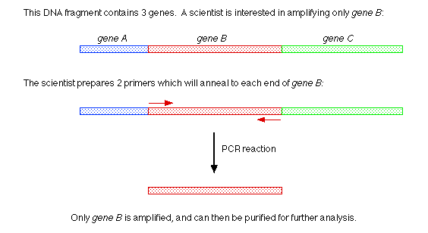

However, in RAPD analysis, the target sequence(s) (to be amplified) is unknown. The scientist will design a primer with an **arbitrary** sequence. In other words, the scientist simply makes up a 10 base pair sequence (or may have a computer randomly generate a 10 bp sequence), then synthesizes the primer. The scientist then carries out a PCR reaction and runs an agarose gel to see if any DNA segments were amplified in the presence of the arbitrary primer.

#### Remember! In order for PCR to occur:

* The primers must anneal in a particular [orientation](http://avery.rutgers.edu/WSSP/StudentScholars/project/archives/onions/orien.html) (such that they point towards each other).
* The primers must anneal within a [reasonable distance](http://avery.rutgers.edu/WSSP/StudentScholars/project/archives/onions/distance.html) of one another.

In this figure which depicts a RAPD reaction, a large fragment of DNA is used the template in a PCR reaction containing many copies of a single arbitrary primer.

**RAPD Reaction #1:** 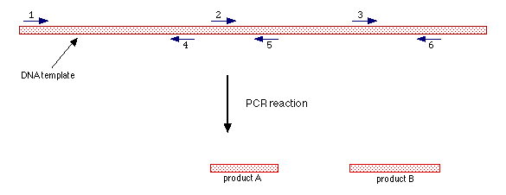

* The arrows represent multiple copies of a primer (all primers (arrows) have the same sequence). The direction of the arrow also indicates the direction in which DNA synthesis will occur.
* The numbers represent locations on the DNA template to which the primers anneal.
* Primers anneal to sites 1, 2, and 3 on the bottom strand of the DNA template and primers anneal to sites 4, 5, and 6 on the top strand of the DNA template.

#### In this example, only 2 RAPD PCR products are formed:

**1)** Product A is produced by PCR amplification of the DNA sequence which lies in between the primers bound at positions 2 and 5.

**2)** Product B is the produced by PCR amplification of the DNA sequence which lies in between the primers bound at positions 3 and 6.

Note that no PCR product is produced by the primers bound at positions 1 and 4 because these primers are [too far apart](http://avery.rutgers.edu/WSSP/StudentScholars/project/archives/onions/distance.html) to allow completion of the PCR reaction.

Note that no PCR products are produced by the primers bound at positions 4 and 2 or positions 5 and 3 because these primer pairs are not [oriented](http://avery.rutgers.edu/WSSP/StudentScholars/project/archives/onions/orien.html) towards each other.

### Finding Differences Between Genomes Using RAPD Analysis

Consider the figure above.

If another DNA template (genome) was obtained from a different (yet related) source, there would probably be some differences in the DNA sequence of the two templates.

Suppose there was a change in sequence at primer annealing site #2:

**RAPD Reaction #2:** 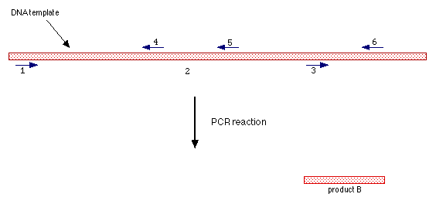

As shown in this figure, the primer is no longer able to anneal to site #2, and thus the PCR product A is not produced. Only product B is produced.

If you were to run the 2 RAPD PCR reactions diagramed above on an agarose gel, this is what you would see:

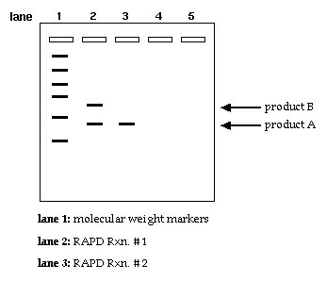

Other links

<http://www.bio-link.org/GMP/Rapdlab1.htm>